CSA6303

THREAT INTELLIGENCE AND NETWORK SECURITY

LAB EXPERIMENTS – 1 TO 5

NAME: HARI HARAN GB
REG NO: 192412390

EXPERIMENT – 1
1. Write a Python program that reads a short business scenario and identifies the most relevant threat intelligence application area for that industry context (e.g., banking fraud prevention, healthcare data protection, e-commerce fraud prevention).
CODING:

def identify_threat_area(scenario):
scenario = scenario.lower()

# Banking and financial fraud
banking_keywords = [
"bank", "banking", "credit card", "debit card",
"transaction", "financial fraud", "online banking",
"payment", "account takeover"
]

# Healthcare data protection
healthcare_keywords = [
"hospital", "healthcare", "patient", "medical",
"health record", "clinical", "doctor", "health data"
]

# E-commerce fraud
ecommerce_keywords = [
"e-commerce", "ecommerce", "online shopping",
"online store", "shopping", "fake order",
"refund fraud", "customer order"
]

# Government / public sector security
government_keywords = [
"government", "ministry", "public sector",
"citizen data", "government portal"
]

# Education security
education_keywords = [
"college", "university", "student",
"education", "school", "student data"
]

# Check the scenario against each application area
if any(keyword in scenario for keyword in banking_keywords):
return "Banking Fraud Prevention"

elif any(keyword in scenario for keyword in healthcare_keywords):
return "Healthcare Data Protection"

elif any(keyword in scenario for keyword in ecommerce_keywords):
return "E-Commerce Fraud Prevention"

elif any(keyword in scenario for keyword in government_keywords):
return "Government and Public Sector Security"

elif any(keyword in scenario for keyword in education_keywords):
return "Education Data Protection"

else:
return "General Cybersecurity Threat Intelligence"

# Main program
print("==============================================")
print(" Threat Intelligence Application Area Finder")
print("==============================================")

scenario = input("\nEnter the business scenario:\n")

result = identify_threat_area(scenario)

print("\n----------------------------------------------")
print("Business Scenario :", scenario)
print("Threat Intelligence Application Area :", result)
print("----------------------------------------------")

OUTPUT:

==============================================
Threat Intelligence Application Area Finder
==============================================

Enter the business scenario:
A bank wants to detect fraudulent credit card transactions and prevent account takeover.

----------------------------------------------
Business Scenario : A bank wants to detect fraudulent credit card transactions and prevent account takeover.
Threat Intelligence Application Area : Banking Fraud Prevention
----------------------------------------------
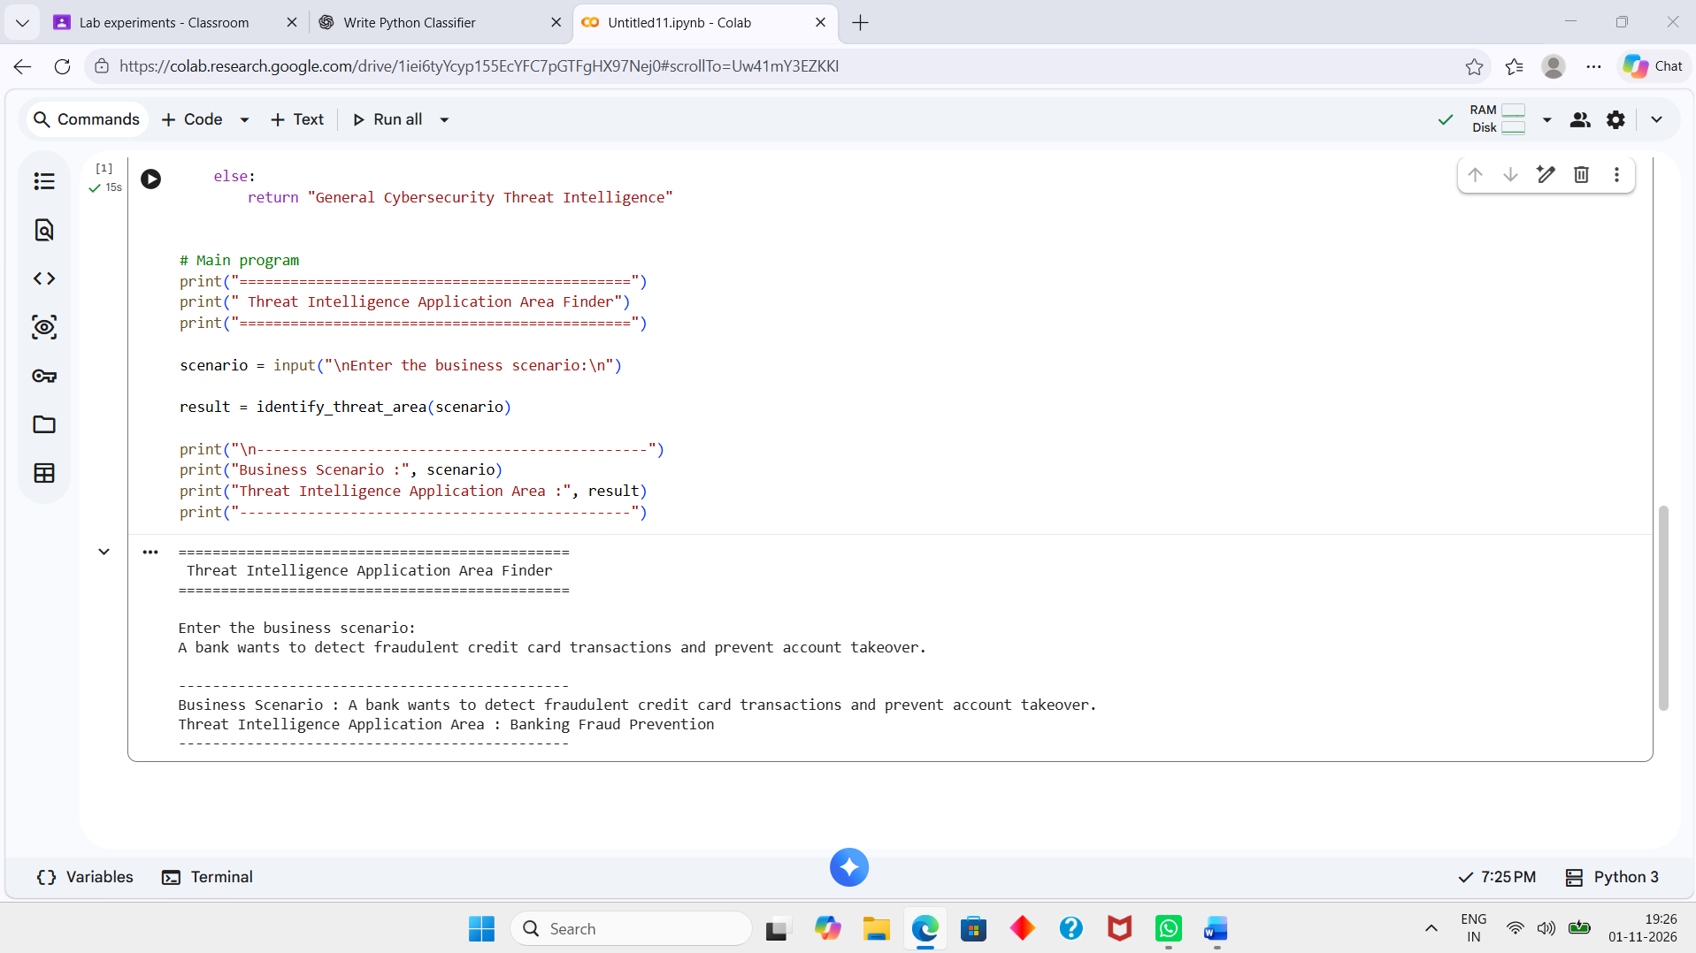

EXPERIMENT – 2
2. Write a Python program to perform a simple vulnerability assessment by implementing a port scanner that identifies open ports on a target host.
CODING:
import socket

def port_scanner(target, start_port, end_port):
print("\n===================================")
print(" SIMPLE PORT SCANNER")
print("===================================")
print("Target Host:", target)
print("Scanning ports:", start_port, "to", end_port)
print("-----------------------------------")

open_ports = []

for port in range(start_port, end_port + 1):
try:
# Create a TCP socket
sock = socket.socket(socket.AF_INET, socket.SOCK_STREAM)

# Set timeout
sock.settimeout(0.5)

# Try to connect to the port
result = sock.connect_ex((target, port))

if result == 0:
print("[OPEN] Port", port)
open_ports.append(port)

sock.close()

except socket.error:
print("Error while scanning port", port)

print("-----------------------------------")
print("Scanning completed.")

if open_ports:
print("Open ports found:", open_ports)
else:
print("No open ports found.")

# Get input from the user
target = input("Enter target IP address or hostname: ")

start_port = int(input("Enter starting port: "))
end_port = int(input("Enter ending port: "))

port_scanner(target, start_port, end_port)

OUTPUT:

Enter target IP address or hostname: 127.0.0.1
Enter starting port: 20
Enter ending port: 100

===================================
SIMPLE PORT SCANNER
===================================
Target Host: 127.0.0.1
Scanning ports: 20 to 100
-----------------------------------
-----------------------------------
Scanning completed.
No open ports found.
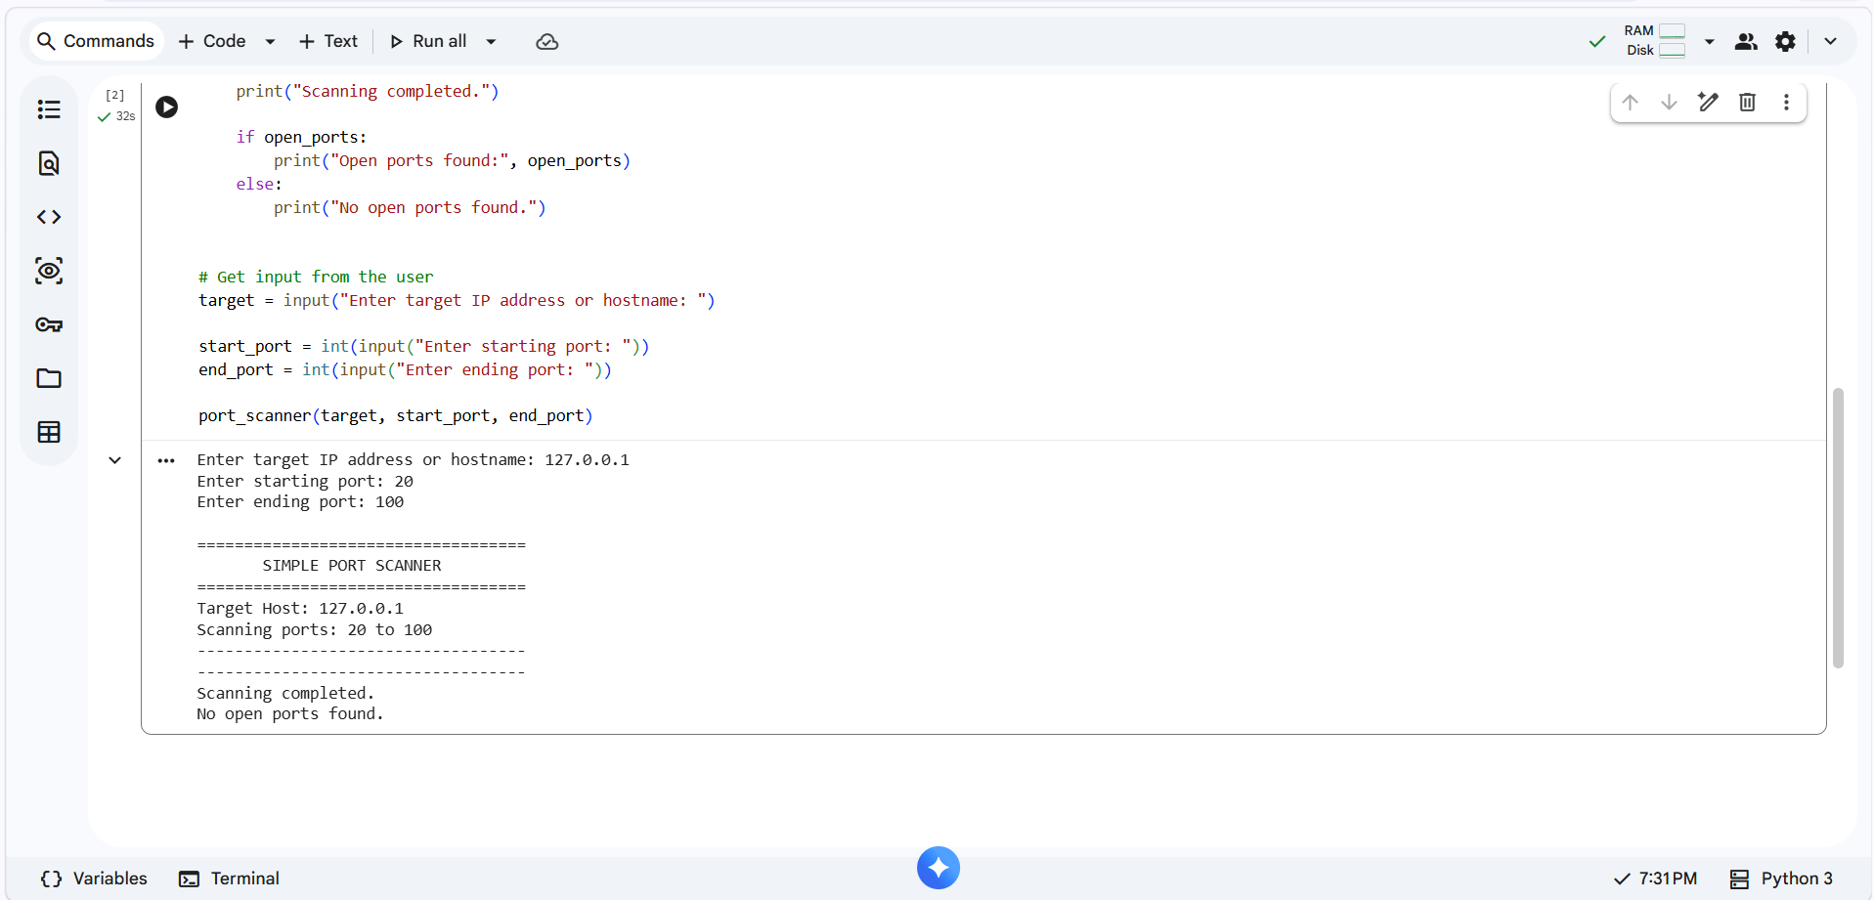

EXPERIMENT – 3
3. Write a Python program to check a draft security policy document for required governance elements (scope, roles and responsibilities, enforcement, review cycle, approval authority) and report which are missing.
CODING:

# Security Policy Governance Element Checker

def check_security_policy(policy_text):

policy = policy_text.lower()

required_elements = {
"Scope": [
"scope",
"applies to",
"covered"
],

"Roles and Responsibilities": [
"roles",
"responsibilities",
"responsible"
],

"Enforcement": [
"enforcement",
"violation",
"disciplinary"
],

"Review Cycle": [
"review cycle",
"review annually",
"review every",
"review period"
],

"Approval Authority": [
"approval authority",
"approved by",
"approval"
]
}

present = []
missing = []

# Check each required governance element
for element, keywords in required_elements.items():

found = False

for keyword in keywords:
if keyword in policy:
found = True
break

if found:
present.append(element)
else:
missing.append(element)

return present, missing

# Main program
print("==============================================")
print(" SECURITY POLICY GOVERNANCE CHECKER")
print("==============================================")

print("\nEnter the draft security policy.")
print("Type END on a new line when finished.\n")

lines = []

while True:
line = input()

if line.upper() == "END":
break

lines.append(line)

policy_text = " ".join(lines)

present, missing = check_security_policy(policy_text)

# Display results
print("\n==============================================")
print(" POLICY ASSESSMENT REPORT")
print("==============================================")

print("\nPresent Governance Elements:")

if present:
for element in present:
print("[✓]", element)
else:
print("None")

print("\nMissing Governance Elements:")

if missing:
for element in missing:
print("[✗]", element)
else:
print("None")

print("\n----------------------------------------------")

if not missing:
print("Result: Policy contains all required governance elements.")
else:
print("Result: Policy requires improvement.")
print("Number of missing elements:", len(missing))

print("----------------------------------------------")

OUTPUT:

==============================================
SECURITY POLICY GOVERNANCE CHECKER
==============================================

Enter the draft security policy.
Type END on a new line when finished.

This security policy applies to all employees and contractors.
The IT Manager is responsible for implementing the security controls. Employees are responsible for following the security requirements.
Violations of this policy may result in disciplinary action.
The policy must be reviewed annually.
END

==============================================
POLICY ASSESSMENT REPORT
==============================================

Present Governance Elements:
[✓] Scope
[✓] Roles and Responsibilities
[✓] Enforcement

Missing Governance Elements:
[✗] Review Cycle
[✗] Approval Authority

----------------------------------------------
Result: Policy requires improvement.
Number of missing elements: 2
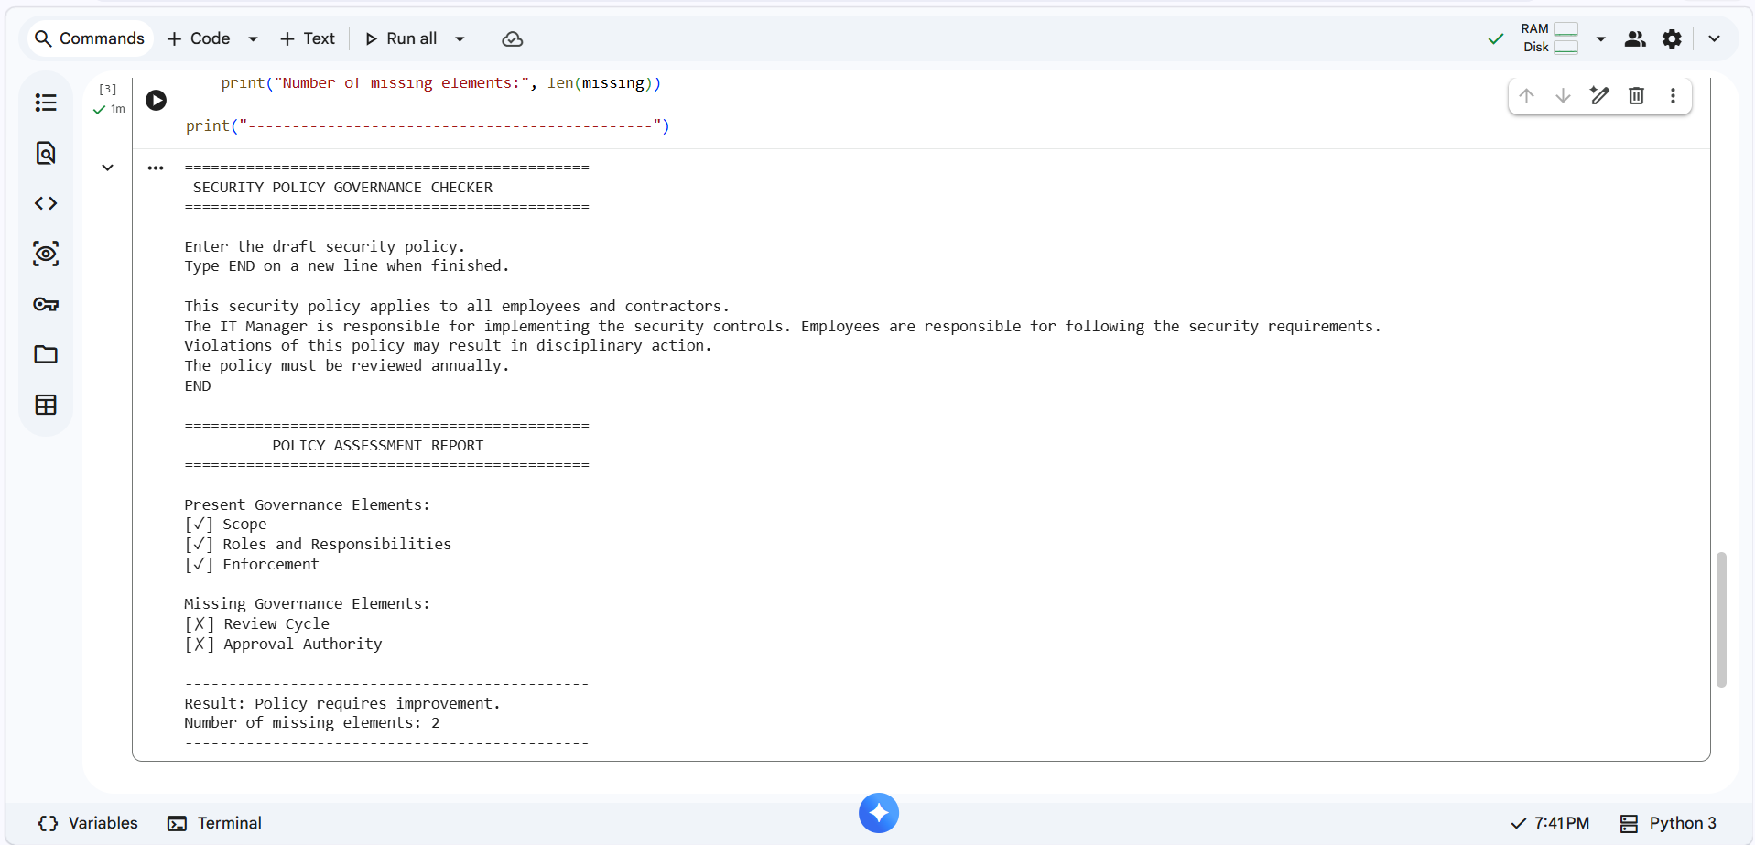
EXPERIMENT – 4
4. Write a Python program to demonstrate the confidentiality property a VPN tunnel provides, showing that data captured in transit is unreadable without the shared key, using a simple symmetric stream cipher as a stand-in for a real VPN's encryption.
CODING:
# VPN Confidentiality Demonstration
# Simple XOR Stream Cipher

def xor_encrypt(data, key):
encrypted = []

for i in range(len(data)):
# XOR each character with the corresponding key character
encrypted_char = ord(data[i]) ^ ord(key[i % len(key)])
encrypted.append(encrypted_char)

return encrypted

def xor_decrypt(encrypted_data, key):
decrypted = ""

for i in range(len(encrypted_data)):
decrypted_char = encrypted_data[i] ^ ord(key[i % len(key)])
decrypted += chr(decrypted_char)

return decrypted

# Sender
print("==============================================")
print(" VPN CONFIDENTIALITY DEMONSTRATION")
print("==============================================")

message = input("\nEnter the message to send: ")
shared_key = input("Enter the shared secret key: ")

# Encrypt the message before transmission
encrypted_data = xor_encrypt(message, shared_key)

print("\n--- Sender Side ---")
print("Original Message :", message)
print("Encrypted Data :", encrypted_data)

# Simulate captured data
print("\n--- Data Captured in Transit ---")
print("Captured Data :", encrypted_data)
print("Readable? : No")

# Receiver decrypts using the correct shared key
decrypted_message = xor_decrypt(encrypted_data, shared_key)

print("\n--- Receiver Side ---")
print("Decrypted Message:", decrypted_message)

# Demonstrate that the wrong key cannot recover the message
wrong_key = input("\nEnter an incorrect key to demonstrate failed decryption: ")

wrong_decryption = xor_decrypt(encrypted_data, wrong_key)

print("\n--- Attacker Without Shared Key ---")
print("Attempted Decryption:", wrong_decryption)
print("Original Message :", message)

if wrong_decryption != message:
print("Result: Data remains unreadable without the shared key.")
else:
print("Result: Message was successfully decrypted.")

OUTPUT:

==============================================
VPN CONFIDENTIALITY DEMONSTRATION
==============================================

Enter the message to send: Transfer confidential data
Enter the shared secret key: VPNKEY

--- Sender Side ---
Original Message : Transfer confidential data
Encrypted Data : [2, 34, 47, 37, 54, 63, 51, 34, 110, 40, 42, 55, 48, 57, 42, 46, 43, 45, 63, 49, 34, 107, 33, 56, 34, 49]

--- Data Captured in Transit ---
Captured Data : [2, 34, 47, 37, 54, 63, 51, 34, 110, 40, 42, 55, 48, 57, 42, 46, 43, 45, 63, 49, 34, 107, 33, 56, 34, 49]
Readable? : No

--- Receiver Side ---
Decrypted Message: Transfer confidential data

Enter an incorrect key to demonstrate failed decryption: WRONG

--- Attacker Without Shared Key ---
Attempted Decryption: Up`kqham o}ewmyybqvu9nvef
Original Message : Transfer confidential data
Result: Data remains unreadable without the shared key.

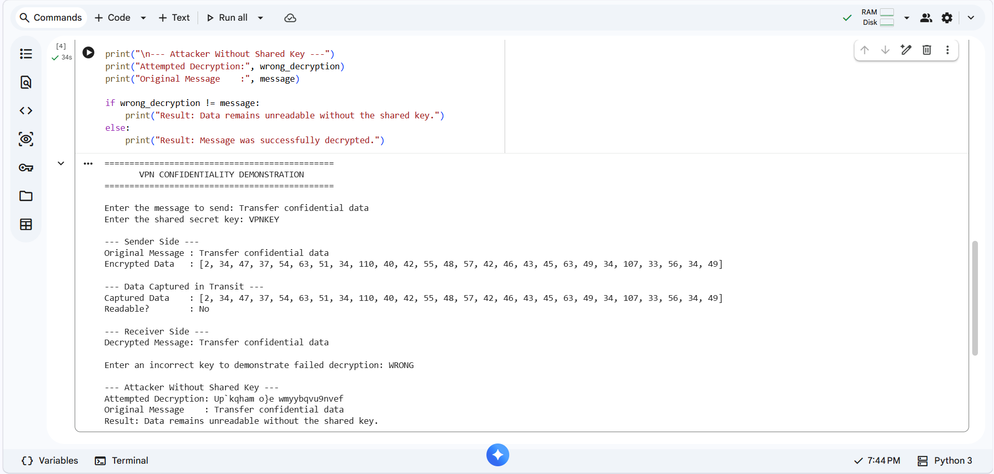

EXPERIMENT – 5
5. Write a Python program using a keyword-based classifier that reads a description of a threat intelligence report and its intended audience, and classifies it as Strategic, Tactical, or Operational.

CODING:

# Threat Intelligence Report Classification
# Classification: Strategic, Tactical, or Operational

def classify_report(description, audience):

text = (description + " " + audience).lower()

# Keywords for Strategic Intelligence
strategic_keywords = [
"executive",
"management",
"senior management",
"c-level",
"board",
"business",
"long-term",
"risk",
"investment",
"strategy",
"strategic",
"business impact"
]

# Keywords for Tactical Intelligence
tactical_keywords = [
"security team",
"soc",
"analyst",
"attacker",
"threat actor",
"ttp",
"tactics",
"techniques",
"procedures",
"mitigation",
"campaign",
"attack method"
]

# Keywords for Operational Intelligence
operational_keywords = [
"incident response",
"soc analyst",
"security engineer",
"ip address",
"ip",
"domain",
"hash",
"malware",
"ioc",
"indicator",
"alert",
"incident",
"real-time"
]

strategic_score = 0
tactical_score = 0
operational_score = 0

# Calculate scores
for keyword in strategic_keywords:
if keyword in text:
strategic_score += 1

for keyword in tactical_keywords:
if keyword in text:
tactical_score += 1

for keyword in operational_keywords:
if keyword in text:
operational_score += 1

# Determine classification
scores = {
"Strategic": strategic_score,
"Tactical": tactical_score,
"Operational": operational_score
}

classification = max(scores, key=scores.get)

return classification, scores

# Main program
print("==============================================")
print(" THREAT INTELLIGENCE REPORT CLASSIFIER")
print("==============================================")

description = input("\nEnter the threat intelligence report description:\n")
audience = input("\nEnter the intended audience:\n")

classification, scores = classify_report(description, audience)

print("\n==============================================")
print(" CLASSIFICATION RESULT")
print("==============================================")

print("Strategic Score :", scores["Strategic"])
print("Tactical Score :", scores["Tactical"])
print("Operational Score :", scores["Operational"])

print("\nReport Classification:", classification)

print("----------------------------------------------")

if classification == "Strategic":
print("Focus: Business risks, trends and long-term decisions.")

elif classification == "Tactical":
print("Focus: Threat actors, TTPs and attack techniques.")

else:
print("Focus: Immediate incidents, IOCs and technical actions.")

print("----------------------------------------------")

OUTPUT:

==============================================
THREAT INTELLIGENCE REPORT CLASSIFIER
==============================================

Enter the threat intelligence report description:
The report analyzes long-term cyber risks and business impact of ransomware attacks.

Enter the intended audience:
Senior management and board members

==============================================
CLASSIFICATION RESULT
==============================================
Strategic Score : 7
Tactical Score : 0
Operational Score : 0

Report Classification: Strategic
----------------------------------------------
Focus: Business risks, trends and long-term decisions.


